**Creative Brief**

Sara Berman

11/7/2018

**Project Title: Amy Poehler**

1. **Project overview**

I want this website to highlight Amy Poehler’s life as a driving force as a woman in the field of comedy. Therefore, my vision is that this website is sophisticated with a creative edge.

1. **Resources**

Copy is available at <https://en.wikipedia.org/wiki/Amy_Poehler>. Although there are some image options on the Wikipedia page there are plenty more on google images. All images should be high quality.

1. **Audience**

Since there are a variety of people that will be viewing this site I want it to be easy to navigate and legible in order to ensure an enjoyable viewing experience for all. Since I will most likely be showing this in my portfolio I would like it to follow my design trends which are clean and simple and mostly typographic based.

1. **Message**

The message of this website is to focus on Amy Poehler’s successful career and how she has navigated herself through the industry.

1. **Tone**

The tone should be serious in that it is showing that Amy Poehler’s success should be appreciated and taken seriously. Although the writing should take on a more serious note, the design of the website and the rendering of both the visual aspects of the typography as well as the images can indicate the humor that her career revolves around.

1. **Visual Style**

My initial Idea is a very clean and simple layout with bright and colorful interactive text that changes colors and illustrate Amy’s very bright and bubbly personality.

Here are some visual examples below.

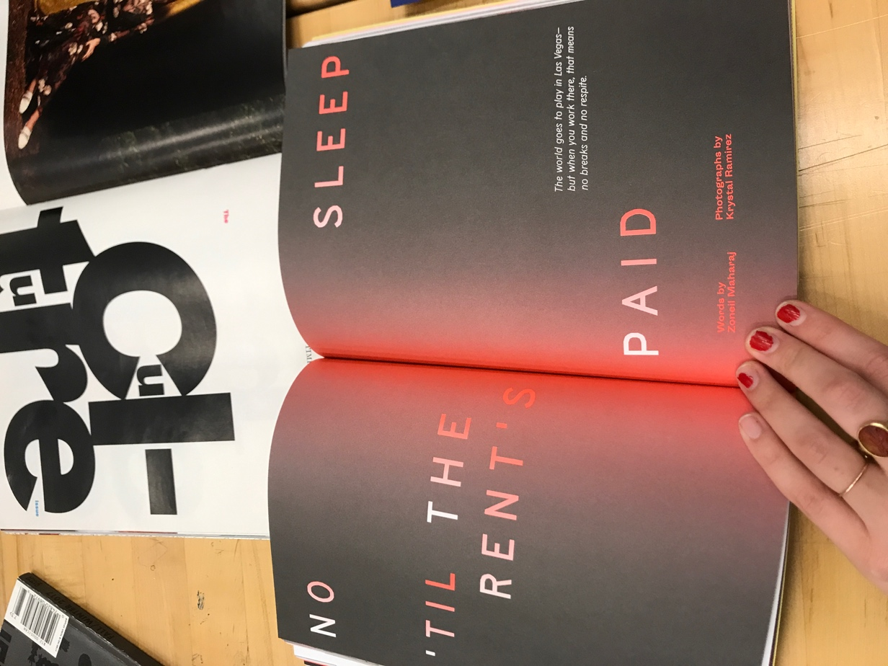

Maybe a simpler background and more vibrant colors, but with typography being a point of visual focus.

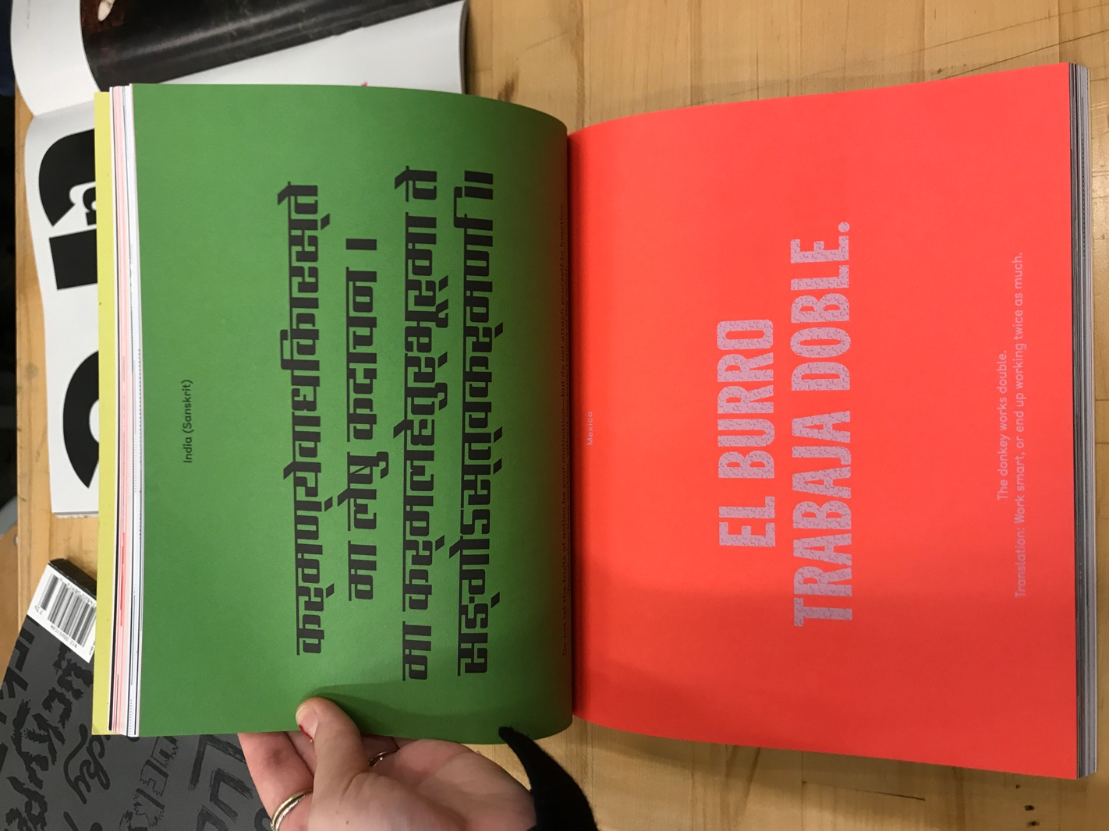

Simplicity and vibrant colors used in the bottom spread